Hong Kong Institute of Vocational Education
IT114105 HD in Software Engineering
ITP4512 Enterprise Software
Topic 1: Introduction to SAP and ABAP

Lab 1 – Log on to SAP and develop ABAP programs

Intended Learning Outcomes
Upon completion of this tutorial/lab, you should be able to:
- Identify how to log in an SAP R/3 system.
- Familiarize with various systems development functions within SAP R/3 system.
- Work out steps for developing ABAP programs within SAP R/3 system.

Exercise 1
- Copy the SAP_A.7z to your USB hard disk as instructed.
- Unzip the SAP_A.7z using 7ZIP.

Exercise 2
- Bring up VMWARE Player.
- Open the VM file under SAP that you have copied and unzipped in Exercise 1.
- Login in as Administrator with password: passw0rd.
- Run SAP R3 Management Console as shown below:
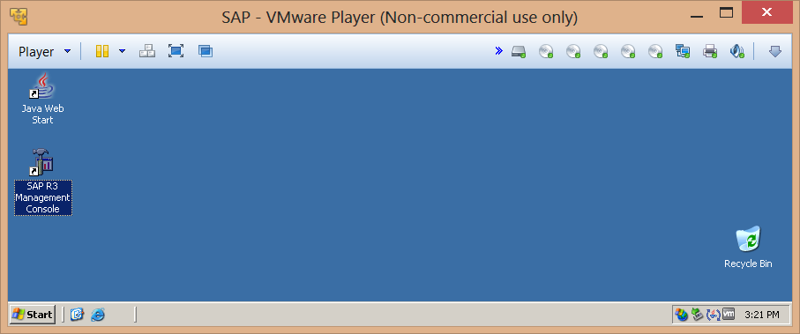
- Expand SAP R/3 Systems, right-click on LW1, and choose start:
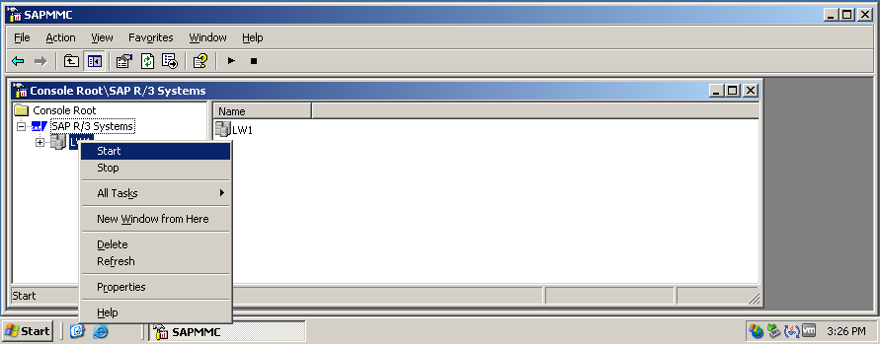
- Wait for the color of LW1 to change to green:
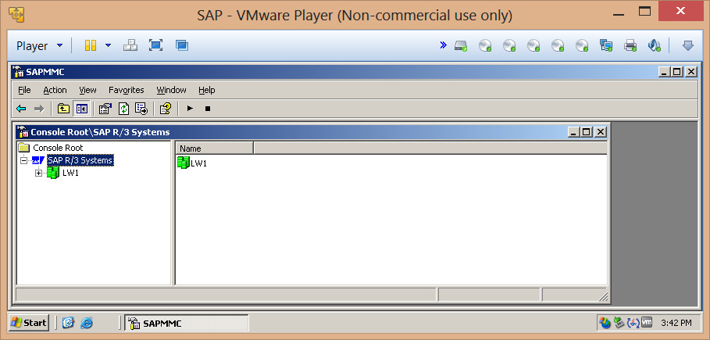
- Run the SAPlogon-Pad:
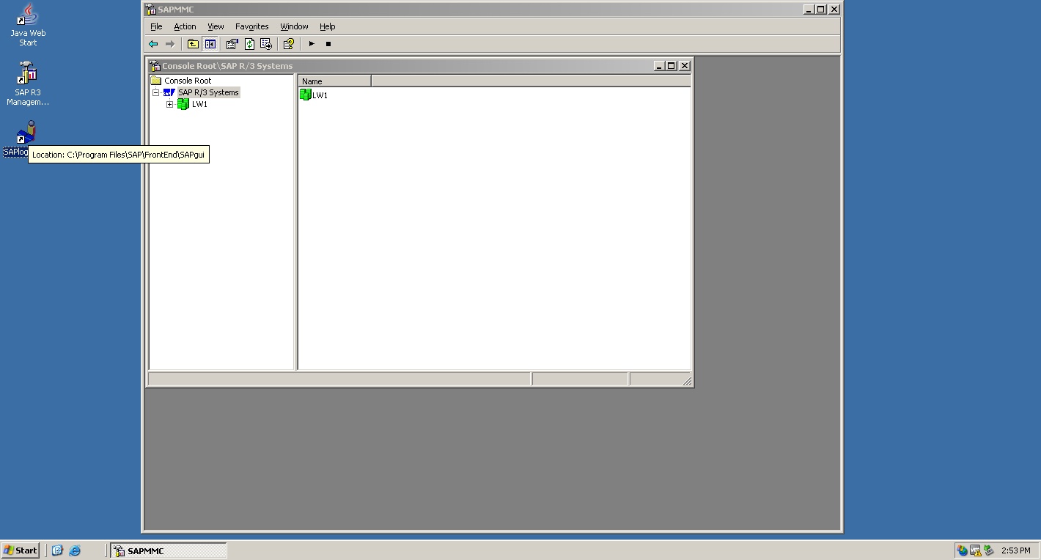

Exercise 3

- Double-click on sap:
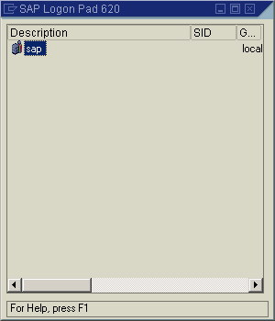
- Enter 810, LWL01 and passw0rd in the first 3 boxes and hit Enter.
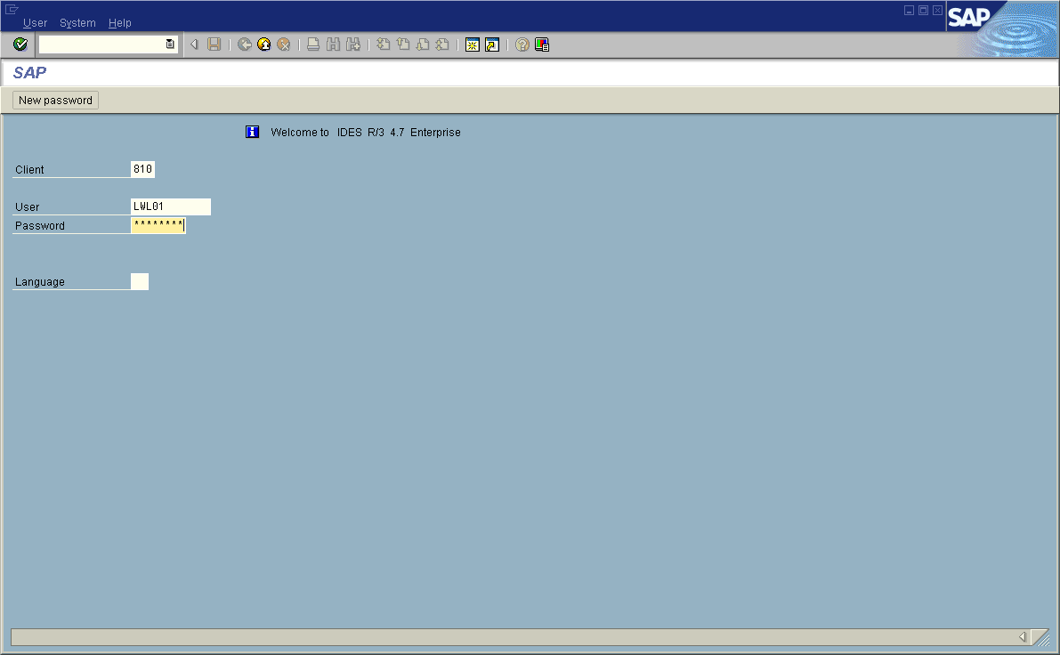
- The following screen will appear:
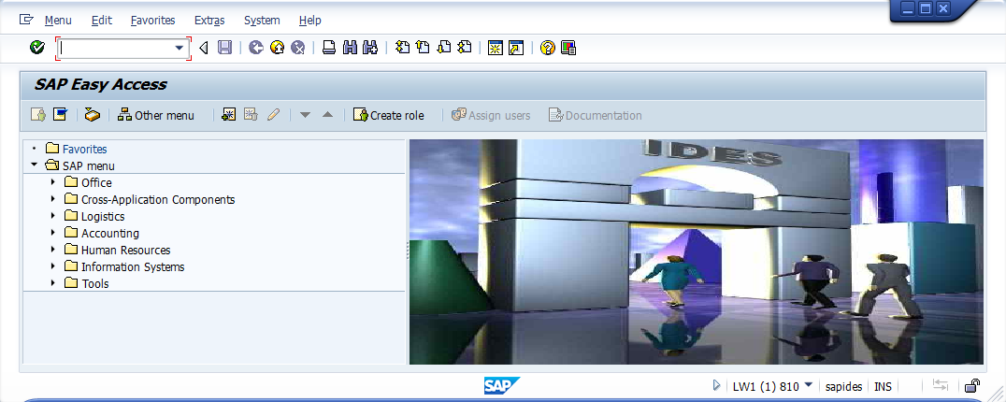

Exercise 4
- Select Extras from the menu and then select Settings.
- Choose Display technical names and click on the ‘tick’ (Continue) icon:
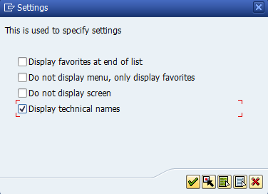
- Expand Tools → ABAP Workbench → Development and notice the transaction code of various functions:
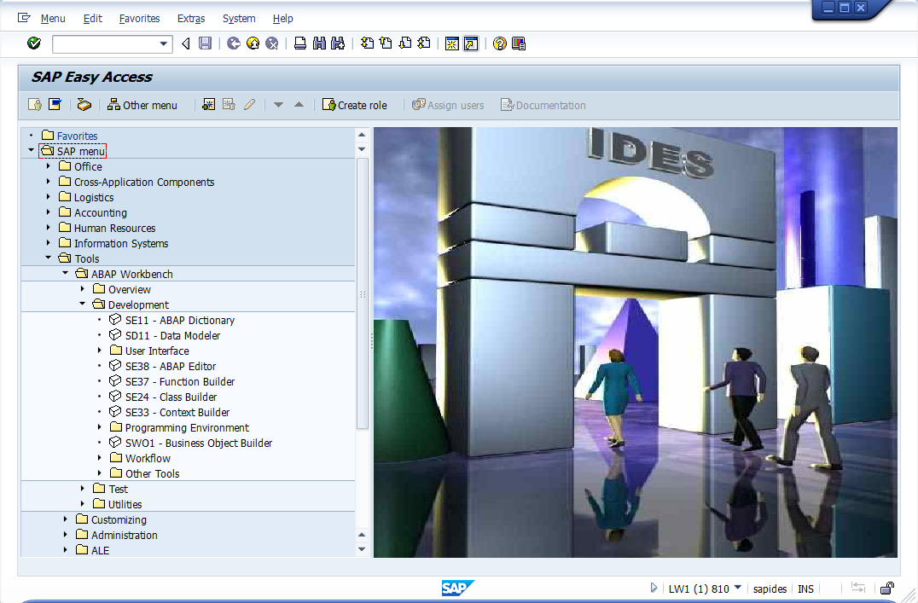

- Select System → User Profile → Own Data and set the following:
  - Last name and First name → your name
  - Logon Language → EN
  - Personal Time Zone → UTC+8
  - Decimal Notation → 1,234,567.89

Exercise 5
- Try to run some SAP business transactions.
- Add the transactions SE11 and SE38 to your favorites
- Try the 3 ways to run a transaction.
- Try to run some SAP Development tools.
- Examine the structures and contents of tables SFLIGHT and SBOOK (Hint: SE11, SE16/SE16N)

Exercise 6
- Run transaction SE38.
- Enter z_hello in the field Program and press the ‘Create’ button:
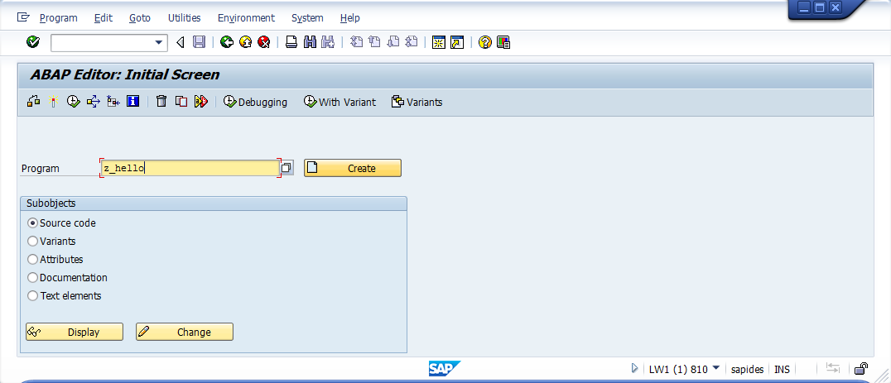
- Type the following as the last line of the program:
Write: ‘Hello to SAP ABAP programming’.
- Activate and run the program.

Congratulations ! You have successfully written your first program in SAP ABAP !

Exercise 7 Shut down the system properly
- Save all the changes from the SAP Logon.
- Exit by clicking the icon continuously or just exit from the SAP Logon.
- Open the “SAP Management Console” at the VM.
- Expand SAP R/3 Systems, right-click on LW1, and choose “Stop”
Wait for the color of LW1 to change to gray.
- Then shut down the server properly by putting some reasons in the comment and press [OK] button.
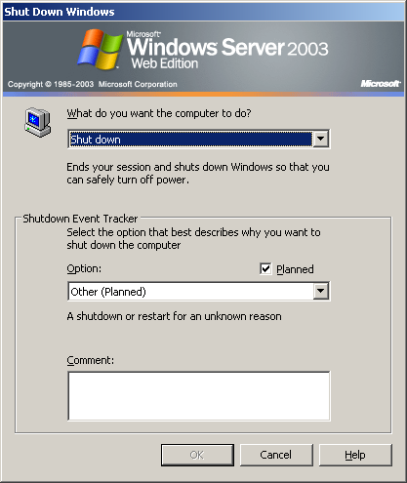

END.

